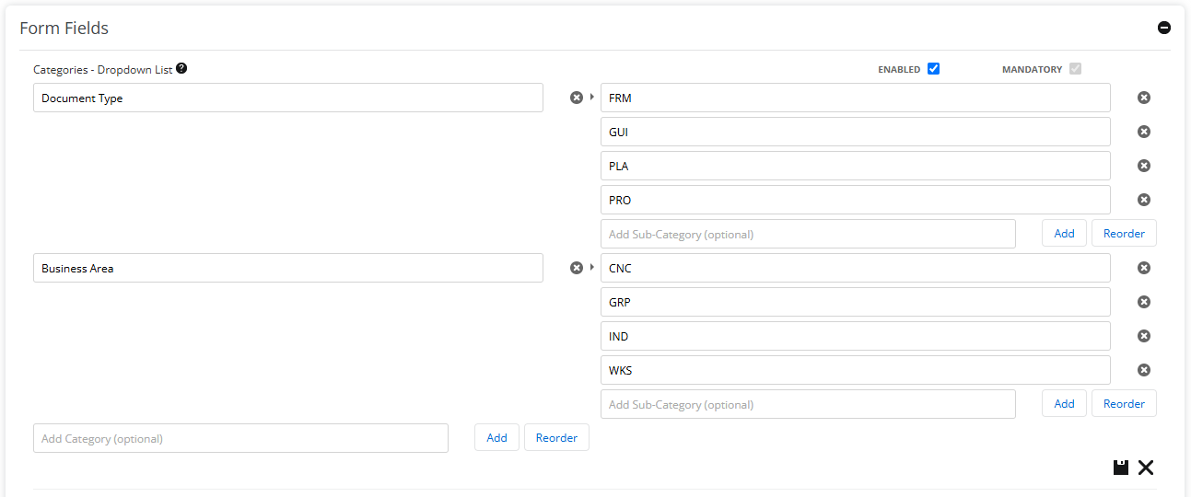





PROCESS AND DOCUMENT REFERENCE NUMBER CONFIGURATION

