When copying text from Microsoft Word/Outlook and pasting it into the Rich Text Editor, the pop-up is part of the Rich Text control implementation with Telerik UI component and it’s by design. The below Telerik demo link shows the same pop-up in the browsers with the copy-pasted text from Word documentation
(https://demos.telerik.com/aspnet-ajax/editor/examples/overview/defaultvb.aspx?show-source=true).
Example:
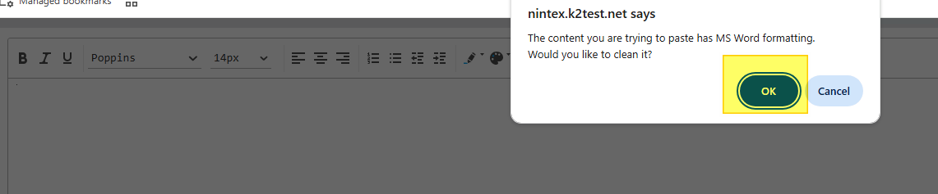
There will be a browser popup that will be displayed, the popup will either remove the MS Word Formatting from the pasted content "OK" and "Cancel" will leave the formatting as is.
For now, let’s start by clicking "OK" and removing the formatting.
The content that I copy over from MS Word has a header and an image. After "OK" had been clicked, we can confirm the HTML content has been clean-up for the web-browsers by switching to HTML tab at the bottom.
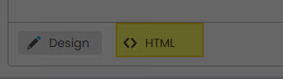
This is the result from HTML tab of the Rich Text control.
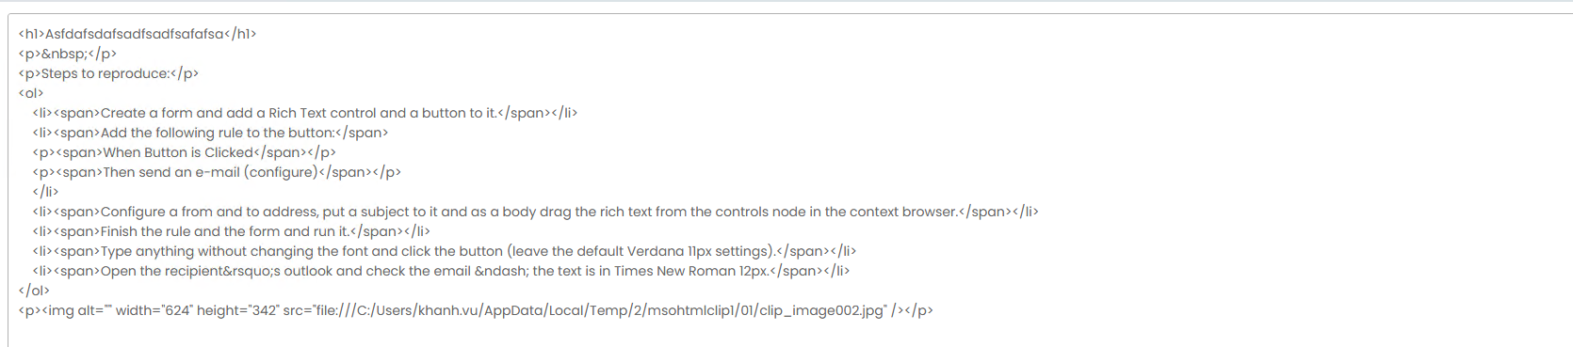

When we compare this against "Cancel", the content looks very different.
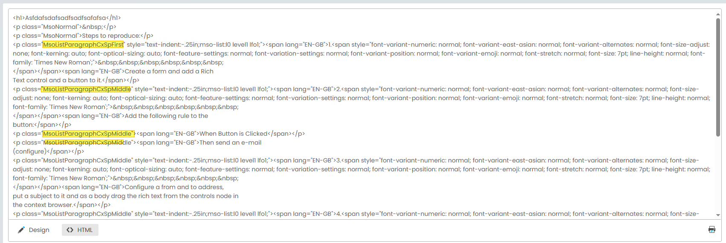
You will notice that the first few lines includes entered spaces, font styling does not match up with the font styling from the actual document. Only by clicking the "OK" button on the browser popup, the control is set up to handle the bad style/formatting, and this helps later on when the MS word content is needed to reload back to the control.

