If multiple attachments are selected they all have a unique name: 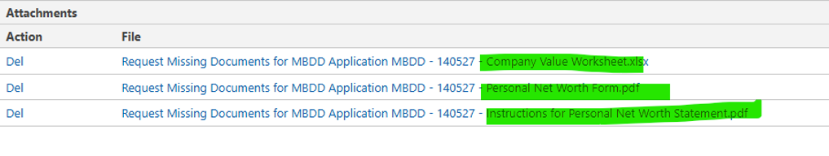
If only one is selected the file loses its unique name:
