Nintex 365 has this option

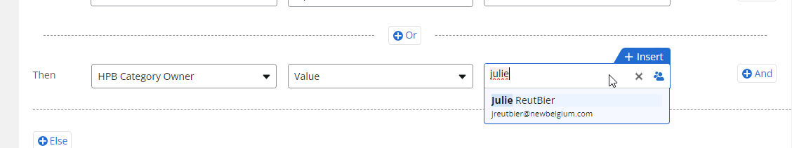

Why doesn’t Nintex Automation cloud
