This is the full screen with the section in question highlighted.
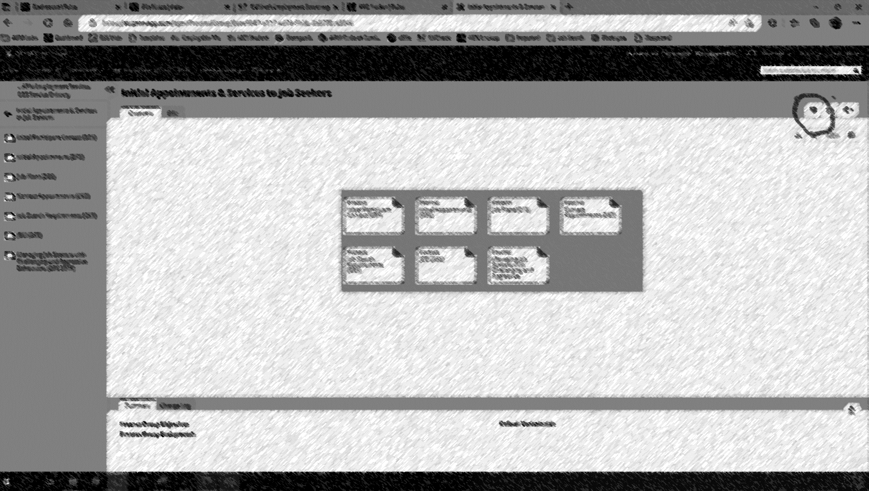
For clarity, this is what the icon currently looks like when NOT a favourite.
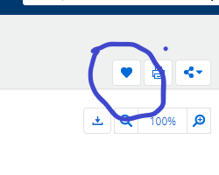
This is what it currently looks like when IS a favourite.
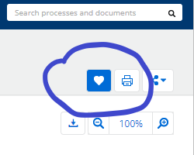

My feedback is this is confusing, my suggestion is something like the following.
For NOT favourite
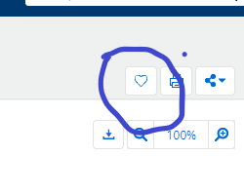
For IS favourite

